Rivka Basman and Mula Ben-Haim: Life Partners
Rivka Basman married Mula Ben-Haim while they were still both stateless and in Europe. As long as he was alive, Mula’s pictures–drawings and color prints– made their way into each of her books of poetry. A sprinkling of his art work sings out in each of these books.
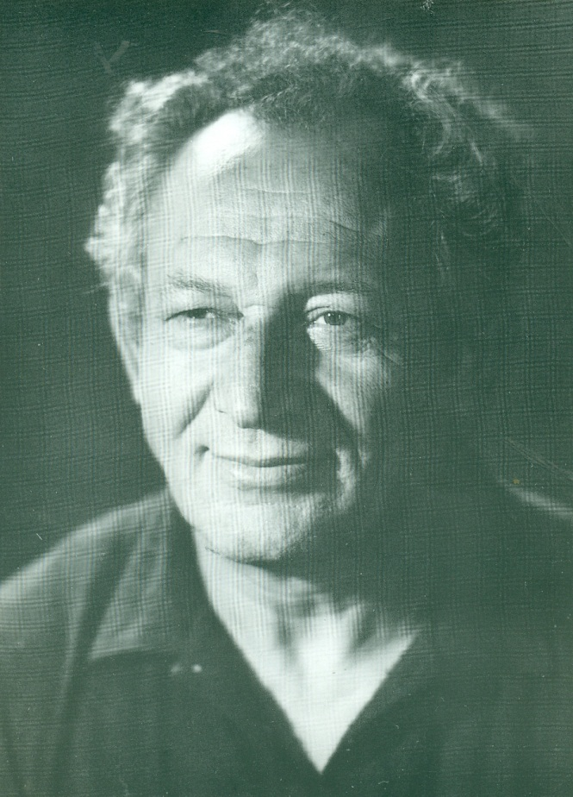
After his death, Rivka added “Ben-Haim “ to her name. What follows is his biography.
Shmuel (Mula) Ben-Haim, (1916-1993)
Shmuel Kochianski, (later “Mula” Ben-Haim) was born in Lida, Poland in 1916. Educated in a “tarbut” school in his home town, he studied music as well as art. His talent in art was recognized early in his life: one of his paintings hung on the wall of a local synagogue in his home town.
In 1936, at the age of 20, he was inducted into the Polish army. At the outbreak of WWII, he saw action as a soldier and was taken prisoner by the Germans. He escaped from prison and found refuge in Vilna, first under Lithuanian, and then under Soviet Russian authority. From 1939-1941 he studied art in Vilna, and was a set manager for the Polish theater.
When Soviet-run Vilna fell to the Nazis in 1941, he fled to Central Asia. In 1945, with the defeat of the Nazis, he returned to Vilna. There he joined his friends from “Ha-shomer Ha-tsa’ir” who planned illegal immigration from Romania to what was then Palestine.
In 1947 he and his wife Rivka Basman immigrated to Palestine (later Israel) and joined kibbutz Ha-ma’apil. With the outbreak of Israel’s was of independence, he served in the Israeli army.
He studied art formally in Israel from 1952-1954; from 1954-1955, he studied art in Paris. He was the secretary of the Union of Kibbutz artists, and after that, head of the Artists and Sculptors Union of Israel.
From 1962-1965, he was the cultural attaché to the Israeli Embassy in Moscow. In those same years, he had four exhibitions in Israel. He participated in group exhibitions all over the world (New York, Boston, Lille, France) and did murals in New York as well as in Tel Aviv. From 1972-1993 he was among the artists who lived in the artists’ colony of Safed. He died in 1993.

